## **Creating a task**

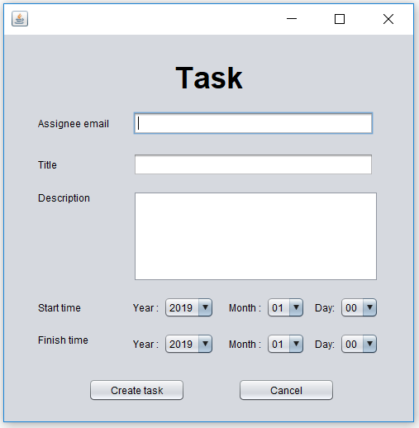

|  |  |
| --- | --- |
| Test | Result |
| Try to create a task with leaving the assignee email input field blank. | Error message pops up informing the user of their mistake, they are returned to the task creation screen after closing the pop up message and no new task is created. |
| Try to create a task with input in assignee email text field but leaving title field blank. | Error message pops up informing the user of their mistake, they are returned to the task creation screen after closing the pop up message and no new task is created. |
| Try to create a task with input in assignee email text field and title text field but leaving description field blank. | Error message pops up informing the user of their mistake, they are returned to the task creation screen after closing the pop up message and no new task is created. |
| Try to create a task with input in all text fields but start time and/or finish time day is left to 00. | Error message pops up informing the user of their mistake, they are returned to the task creation screen after closing the pop up message and no new task is created. |
| Try to create a task with input in all text fields and start time day is not 00 but finish time day is 00. | Error message pops up informing the user of their mistake, they are returned to the task creation screen after closing the pop up message and no new task is created. |
| Try to create a task with all inputs populated but the assignee email does not correspond to that of a registered user within the database. | Error message pops up informing the user of their mistake, they are returned to the task creation screen after closing the pop up message and no new task is created. |
| Try to create a task with all inputs populated and assignee email is valid but the chosen finish time is before the chosen start time. | Error message pops up informing the user of their mistake, they are returned to the task creation screen after closing the pop up message and no new task is created. |
| Try to create a task with all inputs populated but the user corresponding to the assignee email is not part of the group which the task is being created in. | Error message pops up informing the user of their mistake, they are returned to the task creation screen after closing the pop up message and no new task is created. |
| Try to create a task with all valid inputs. | Task creation is successful. Task is added to the database and the task creation window is closed. |
| Cancel button is pressed. | The task creation form is discarded and no further action is done in regards to task creation. |

## **Editing an existing task**

Same input validation as for creating a task.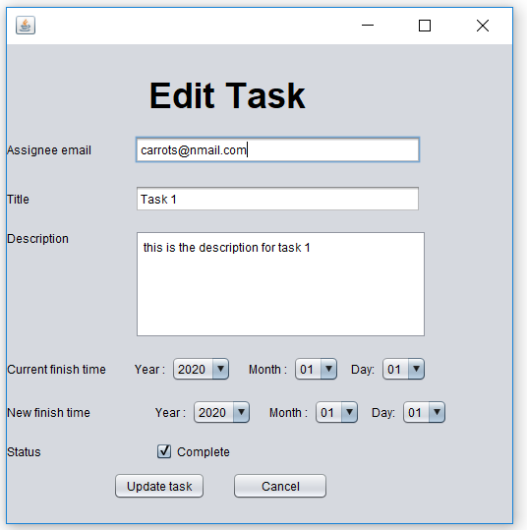

|  |  |
| --- | --- |
| Test | Result |
| All inputs are valid and update task button is pressed. | Task update is successful. The task has its details updated in the database with the provided ones by the form. |

## 

## **Logging into the system**

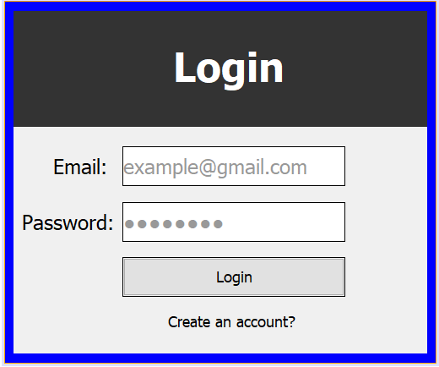

|  |  |
| --- | --- |
| Test | Result |
| When the user tries to login without inputting email or password | An error message will pop up telling the user has inputted an invalid email or password. After closing the message user gets another attempt to login |
| When the user tries to login by inputting wrong email or password | An error message will pop up telling the user he/she has inputted either wrong email or password. |
| When the user press the “create an account” text | A new register interface will show up and closes the login interface |
| When the user presses the login button and it works | The system will close the login interface and open up this interface |

## 

## **Registering into the system**

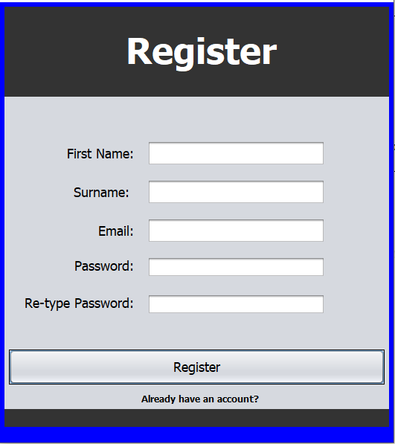

|  |  |
| --- | --- |
| Test | Result |
| When the user inputs nothing into the fields given | This message will pop up to tell the user that they have inputted nothing into one of the text field |
| When the user inputs nothing into the password text field or inputs character less than 7 | This message will pop up to tell user that they need a stronger password therefore, the password must be 7 characters long or longer |
| When the user inputs two different password into the “Password” and “Re-Type password” text field | This message will show up to tell the user that the password he/she input does not match with each other |
| When the user registers with an email that has already been registered in the database | This message will pop up to tell the user that the email that they used has already been registered |
| When the user presses the register button with all the correct inputs (Successfully Registers) | This message will show up to tell the user that they have an successfully made an account |
| When the user presses the “Already have an account” text | A new login interface will show up and closes the register interface |

**Logging Out**

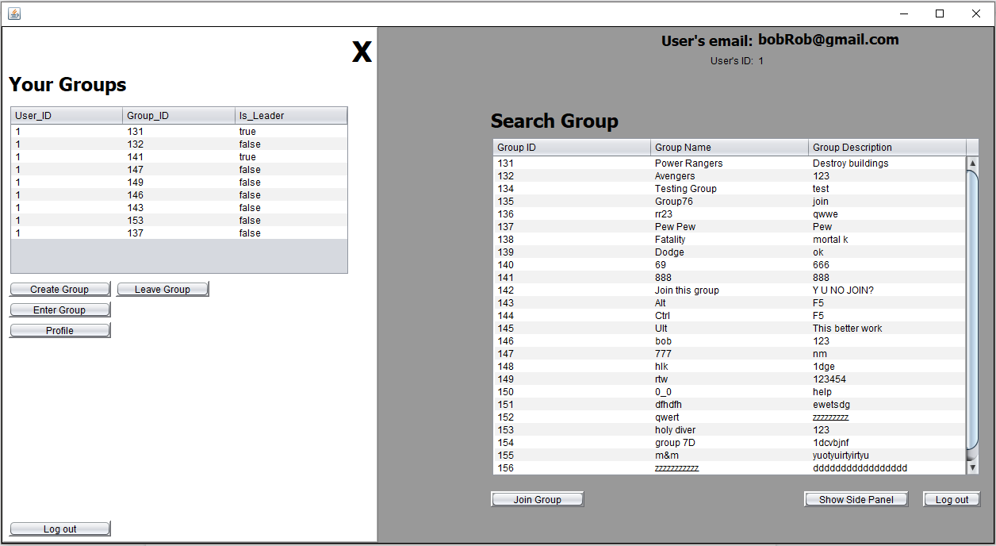

|  |  |
| --- | --- |
| Test | Result |
| When the user clicks on the Log out button | It will close out the main interface and opens up a new login interface |

**Closing and Opening the side panel**



|  |  |
| --- | --- |
| Test | Result |
| When the user clicks the Black cross |  |
| When the user presses the “Show side panel” button after the side panel is hidden |  |
| When the user presses the “Show side panel” button when the side panel is still visible | Nothing happens |

**Joining a group**

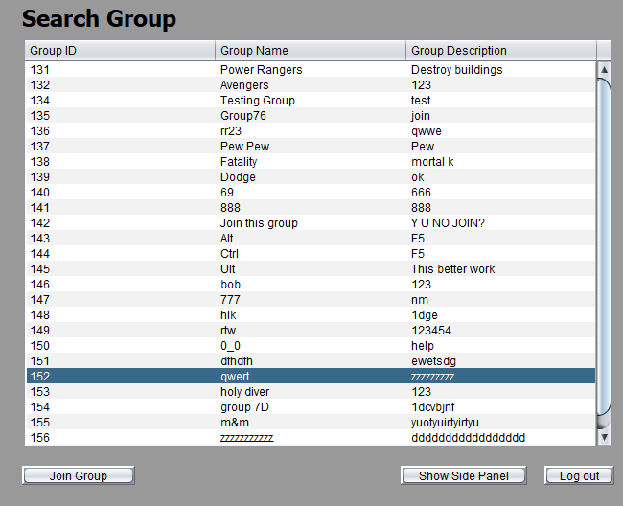

|  |  |
| --- | --- |
| Test | Result |
| When the user joins a group that he/she has not joined already | This message will pop up to inform the user that he/she has joined the group and it will show the group in the “Your Group” table |
| When the user tries to join a group that he/she has already joined | This message will pop up to inform the user that he/she is already in the group |

### **Profile Screen**

|  |  |
| --- | --- |
| Test | Result |
| “Edit” button pressed. | The buttons “change password” and “delete account” appear. |
| “Edit” button is pressed after already being pressed. | The buttons “change password” and “delete account” disappear. |
| Change password button pressed. | A pop up screen appears asking the user to enter their new password. |
| Attempt to change password while leaving new password field blank. | Password of the user is updated within the database and the pop up is discarded. |
| Attempt to change password while entering a new password into the pop up field. | Password of the user is updated within the database and the pop up is discarded. |
| “Cancel” button is pressed on password pop up field. | The pop up is discarded, no further action is taken towards updating the password. |
| “Delete account” button is pressed. | A pop up confirmation screen appears. |
| “No” button is pressed on the confirmation pop up menu for “delete account”. | Pop up menu is discarded and no further action is taken towards account deletion. |
| “Yes” button is pressed on the confirmation pop up menu for “delete account”. | Account of the user is deleted from the database and the pop up is discarded. |
| “View” button on a task is pressed. | A form pops up with all the details of the task which are non editable. |
| “Back” button is pressed on the task viewing form. | The form is discarded. |
| “Complete” checkbox of a task is clicked. | The “complete” checkbox of that task is ticked, is now uneditable and the task status is updated to complete within the database. |

### **Group Leader Screen**

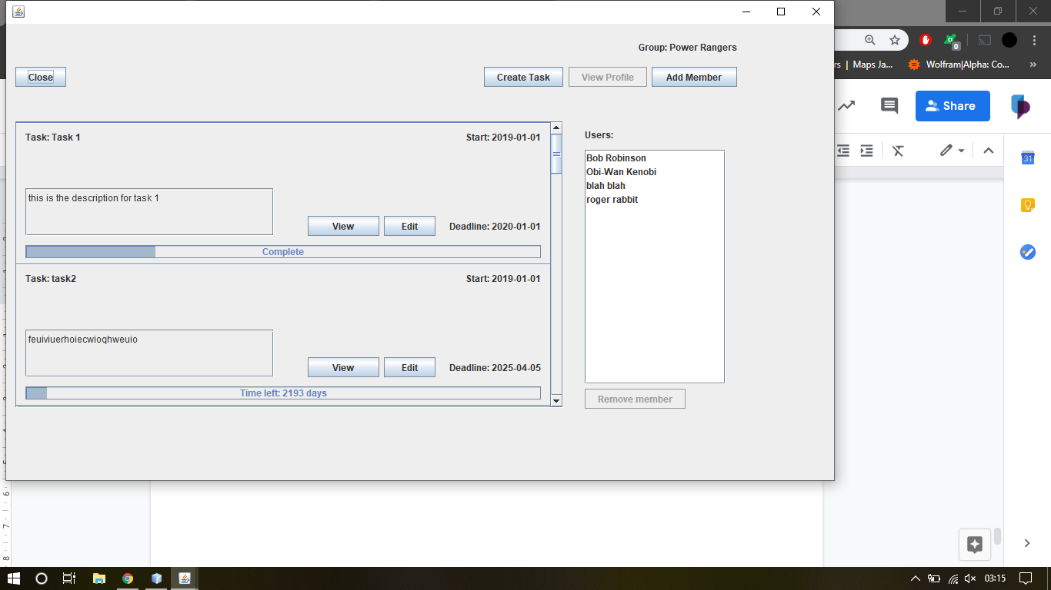

|  |  |
| --- | --- |
| Test | Result |
| “Close” is pressed. | Group Leader screen is discarded. |
| “Create task” is pressed. | Group Leader screen is discarded and a form of task creation appears. |
| A user is selected from the users table who is not the currently logged in user and “view profile” is pressed. | A user profile page pops up with the user’s id, name and his current tasks. |
| A user is selected from the users table who is the currently logged in user and “view profile” is pressed. | A user profile screen pops up with the current user’s details. |
| “Add member” is pressed | The group screen is discarded and a pop up menu appears asking the user to input the email of the member they want to add. |
| The user attempts to add a member while leaving the email field in the pop up blank. | A message appears asking the user to input an email into the field. |
| The user attempts to add a member already in the group. | The user is added to the group list again. |
| The user attempts to add a non existing member. | A message appears informing the user of the error. |
| “Cancel” is pressed on the pop up screen. | The pop up screen is discarded and the group page is reloaded. |
| A user that is not the leader is selected from the users table and “Remove member” is pressed. | The user gets removed from the group. |
| A user that is the leader is selected from the users table and “Remove member” is pressed. | An error message pops up saying that the leader of the group cannot be removed. |
| “View” is pressed on a task. | A task view form pops up with that task’s details. |
| “Edit” is pressed on a task. | A task edit form pops up with the current details of the task. |

### **Group Member Screen**

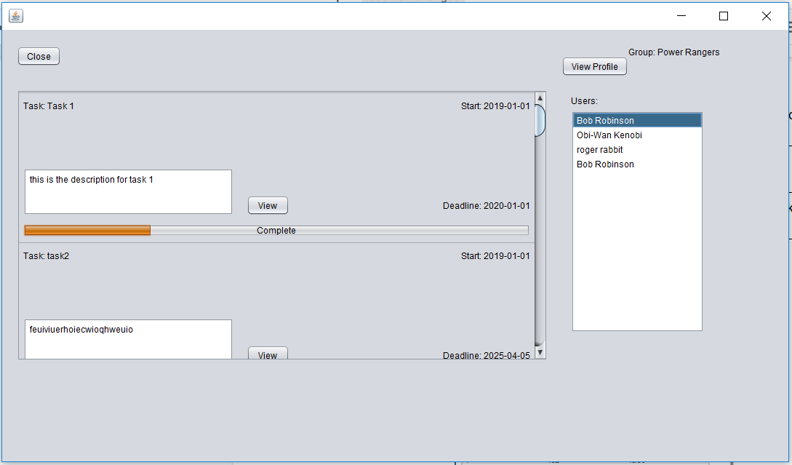

|  |  |
| --- | --- |
| Test | Result |
| “View profile” is pressed and a user is selected from the users table who is not the current user. | A user profile view screen appears with the selected user’s id, name and current tasks. |
| “View profile” is pressed and a user who is the current user is selected from the users table. | A user profile page with the current user’s details is loaded up. |
| “View” is pressed on a task. | A task view from is loaded up with the selected task’s details. |
| “Close” button is pressed. | The group screen is discarded. |

### **User’s groups**

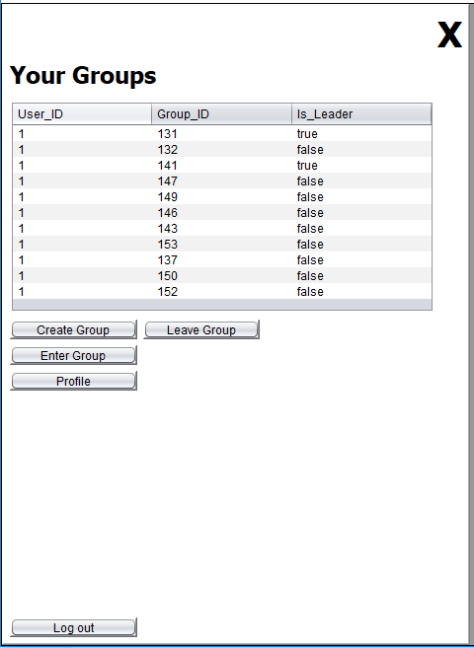

|  |  |
| --- | --- |
| Test | Result |
| “Create Group” button is pressed | A form for a new group creation appears and the main screen gets discarded. |
| No group is selected from the table and “Enter Group” is pressed. | Nothing happens. |
| A group is selected from the table in which the user is a leader and “Enter Group” is pressed. | A group leader screen appears along with a popup informing the user which group that is and that they are the leader of that group. |
| A group is selected from the table in which the user is not a leader and “Enter Group” is pressed. | A member screen page appears along with a popup message informing the user which group it is. |
| “Profile” button is clicked. | User is taken to their profile page. |
| “Log out” is pressed. | User is taken back to the login page. |
| The “X” in the top right is pressed. | The panel gets closed. |

Creating a new group

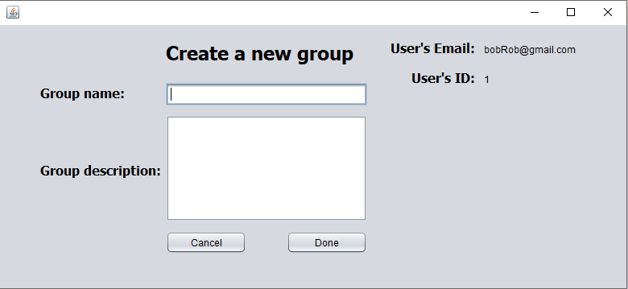

|  |  |
| --- | --- |
| Test | Result |
| When the user does not input anything into the group name or group description text field and then presses the Done button | This message will pop up telling the user that they can not leave an empty field |
| When the user presses the Cancel button | This interface will open up and closes the Create_group interface. In other words it will return to the previous interface |
| When the user inputs a group name and description and presses the Done button | This message will open up to tell the user that they have successfully created a group |